Application Form
Business Development Manager

Thank you for your interest in Wasafiri and our work!

Here’s what we require from you in order for us to consider your application for the role:

- Your completed application form
Please complete the form contained in the following section. This will help us get a better sense of our background, skills and experience as they relate to the position.

- Your curriculum vitae
Please take note of the following:
- We’d really appreciate it if your CV is no longer than 3 pages in total; please note that we won’t be in a position to accept CVs that are more than 3 pages.
- As a minimum, please ensure your CV addresses the following aspects of your experience and background;
  - Your educational background
  - Your employment history
  - The countries you’ve worked in
  - The key skills you bring

- Three professional references
Please provide the details of three professional references in the form below. We will only contact them with your permission, and they will be invaluable to help us get to know you better.

A couple of final notes
- We don’t require you to write a separate cover letter
- At this stage we won’t need any samples of your work
- Forgive us if we are delayed in responding to your application – we expect to receive quite a large number of applications, and want to ensure we undertake this process with quality!

Application Form

Before you start; a couple of points to consider
- Please adhere to the word and page limits. This will make your and our lives easier!

- Please respond with quality. We really value the quality of your written work; we value well-structured content that makes a point clearly and succinctly. Bullet points are appreciated!!

- PERSONAL DETAILS
Name:
Email:
Current Base:

Current Job Title & Organisation:
Linked In Profile:

Technology expertise:  (Please number 1-5) | Word:
 | Excel:
 | Powerpoint:
 | Other:
- CULTURE & WASAFIRI SPIRIT
Experience working within a purpose-driven start-up environment. We are a small, close-knit team driven by a shared ambition to increase our impact on complex global challenges such as poverty and conflict. What are the attributes do you feel it takes to work and contribute effectively in such an environment? How will you bring these into the role?
(Max 150 words)

Please reply here:
Xxx

- MARKET & CLIENT AWARENESS & ENGAGEMENT
Experience working with potential clients and donors: The role requires extensive knowledge of how potential donors and clients operate – in terms of priorities, routes to market, procurement approaches and supplier selection. With which donors and clients do you have the greatest experience? What approaches would you use to monitor their changing priorities and trends?
(Max 150 words)

Please reply here:
Xxx

- OPPORTUNITY IDENTIFICATION & PIPELINE MANAGEMENT
Opportunity identification – In the role, you will play a key role in identifying new tenders and commercial opportunities as they come out. What are some of the most important processes / mechanisms / approaches you would use for spotting new opportunities?
(Max 150 Words)

Please reply here:
Xx

- BID COORDINATION & PROPOSAL DEVELOPMENT
Bid Coordination – The BD Manager will coordinate a range of proposal development processes, Please provide 2-3 examples of successful proposals you have been involved in. Ensure you indicate your role, the financial scale, the technical focus of the proposal and highlight any specific challenges in the preparation of the bid.
(Max 200 words)

Please reply here:
Xx

Proposal Development - We expect the BD Manager to be intimately involved in the design of proposals, working with our portfolio and technical leads. This could include recruiting the project team, drafting of the budget and workplan, engaging with consortium partners, packaging the bid documentation. Please tell us which aspects of proposal development you are most experienced and familiar with.
(Max 200 words)

Please reply here:
Xx

- OTHER
Are there any other details we should know – Please add any further information you feel may be helpful in assessing your application. (Max 250 words)

Please reply here:
Xx

- PROFESSIONAL REFERENCES x 3
Please list Name, Title, Organisation, Email, Telephone:

- X
- X
- X

Finally – a big thank you!
We really appreciate the time and effort you’ve taken to complete this application. It’ll give us a great insight into your suitability for the role, so; good luck and we will be in touch soon!

The Dock, Wilbury Villas, Brighton, BN3 6AH, United Kingdom Europe
The Collider, 1 Haywood St., Asheville, NC 28801, USA North America
Ikigai House, General Mathenge Drive, Spring Valley, Nairobi, Kenya Africa
We are committed to ethical and environmental best practice. For further information, please see here.
enquiry@wasafirihub.com | www.wasafirihub.com
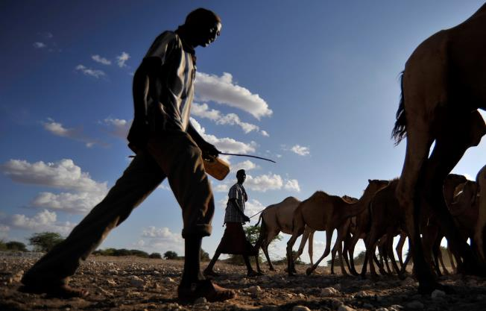
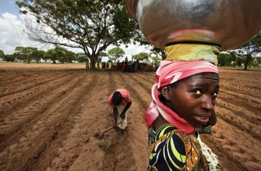
CLIMATE &
ENVIRONMENT
FOOD SYSTEMS &
INCLUSIVE GROWTH
CONFLICT &
GOVERNANCE
A global consultancy, incubator and institute helping leaders drive transformative impact at scale

