Application Form
Managing Director

Thank you for your interest in Wasafiri and our work!
Here’s what we require from you in order for us to consider your application for the role:

- Your completed application form
Please complete the form contained in the following section. This will help us get a better sense of your background, skills and experience as they relate to the position.

- Your curriculum vitae
Please take note of the following:
- We’d really appreciate it if your CV is no longer than 4 pages in total; please note that we won’t be in a position to accept CVs that are longer than this limit
- As a minimum, please ensure your CV addresses the following aspects of your experience and background;
  - Your educational background
  - Your employment history
  - The countries you’ve worked in
  - The key skills and expertise you bring

- Three professional references
Please provide the details of three professional references in the form below. We will only contact them with your permission; they will help us get to know you better.

A couple of final notes
- We don’t require you to write a separate cover letter
- At this stage we won’t need any samples of your work
- We encourage informal discussions before any formal application; this will help you get a sense as to whether its worth the effort! Please email opportunities@wasafirihub.com to request a discussion with Kate Simpson

Application Form

Before you start; a couple of points to consider
- Please adhere to the word and page limits. This will make your and our lives easier!

- Please respond with quality. We really value the quality of your written work; we value well-structured content that makes a point clearly and succinctly. Bullet points are appreciated!!

- PERSONAL DETAILS
Name:
Email:
Current Location:

Current Job Title & Organisation:
Technology expertise:  (Please number 1-5) | Word:
 | Excel:
 | PowerPoint:
 | Other:
- MOTIVATION
Your ambitions. Please tell us; what excites you about becoming Wasafiri’s next Managing Director? Give us a sense of the impact you’d like to create in the world, and how this role aligns with your professional ambitions. (Max 300 words)
xx
- LEADERSHIP
Leadership - This role requires experience leading organisations or initiatives at senior levels. Please list your three most relevant roles and give us an insight into your approach to leadership. (We’re not interested in fancy jargon or theory; we’re curious to learn more about the way you think of leadership, how you show up and practice leadership in the messy realities of leading a complex organisation or initiative) (Max 250 words)
xxx
Culture – We operate on principles of self-management. What draws you to an organisation run in this way and what challenges do you imagine this approach might pose for you as Managing Director? (Read here for more; https://www.wasafirihub.com/our-experiences-with-self-organising-principles/) (Max 150 words)
xxx
Entrepreneurialism - We require someone with the energy to create new things. Please share a brief example of when you’ve brought some new initiative to life; we’re interested to know 2-3 insights you’ve learned from this experience and how that would inform your approach to the role. (Max 250 words)

Xxx

Commercial - As a small business we must balance commercial and financial discipline with our appetite for growth and innovation. Imagine a senior member of staff introduces an exciting idea they are keen to invest in; what questions would you ask and how would you decide if this was an investment worth making? (Max 250 words)

Xxx

- CREATING CHANGE
Delivery – The role will also require some working directly with clients, helping to create change. From your own experience, which areas of our portfolios would you feel most able and excited to contribute to (Climate & Nature, Conflict & Governance, Food Systems & Inclusive Growth)? Please point to several examples and summarise the impact you’ve had in these roles. (Max 200 words)

Xxx

Systemcraft – Systemcraft lies at the core of Wasafiri’s approach to change. (https://www.wasafirihub.com/systemcraft/). What draws you to this approach? Please also tell us something about this approach you’re less confident in, or might wish to challenge. (Max 250 words)

Xxx

- OTHER
Please add any further information you feel might be helpful in assessing your application. (Max 250 words)

Xxx

- PROFESSIONAL REFERENCES x 3
Please list Name, Title, Organisation, Email, Telephone:

- X
- X
- X

Finally – a big thank you!

We really appreciate the time and effort you’ve taken to complete this application. It’ll give us a great insight into your suitability for the role, so, good luck and we will be in touch soon!

The Dock, Wilbury Villas, Brighton, BN3 6AH, United Kingdom Europe
The Collider, 1 Haywood St., Asheville, NC 28801, USA North America
Ikigai House, General Mathenge Drive, Spring Valley, Nairobi, Kenya Africa
We are committed to ethical and environmental best practice. For further information, please see here.
enquiry@wasafirihub.com | www.wasafirihub.com
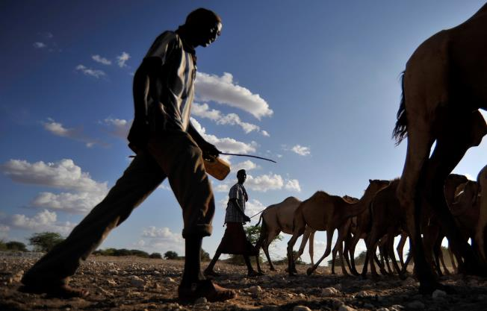
CLIMATE &
ENVIRONMENT
FOOD SYSTEMS &
INCLUSIVE GROWTH
CONFLICT &
GOVERNANCE
A global consultancy, incubator and institute helping leaders drive transformative impact at scale

